

Raising a Repair Request

Work Instruction

Document metadata
Issue Date | 26 August 2022
Status | Live
Produced by | Jason.Briggs@mha.org.uk
Test / Passed | Passed

Version control
No. | Issue Date | Author | Issue Reason
1.0 | 26 August 2022 | Jason Briggs | Initial release

Responsible, Accountable, Consult, Inform
Role & Name  (if applicable) | Management All Levels | Repair Requestor | - | -
RACI category | Accountable | Responsible | Consult | Inform

Activity Overview
The purpose of this Work Instruction is to show the reader how to submit information through the new “Raise a Repair” Google Form. The report is to be submitted to raise new repair requests only.

Do not start this process until you have all the information. The form will not allow for ‘half submissions’ so please ensure you have all the information before submitting.

Systems to be used
Raising a Repair Google Form

Contents
Activity Overview 1
Systems to be used 1
1 Checklist 2
2 Procedure 2
2.1 Procedure schedule 2
2.2 Ste-by-step tasks 2
3 Troubleshooting 4
3.1 Error made before submitting your information 4
3.2 Error in the information submitted 5

- Checklist
Task to be completed | Complete?
Provide contact information
Provide repair issue information
Submit repair request

- Procedure
  - Procedure schedule
This process should be followed when a new repair request needs to be raised.

  - Ste-by-step tasks
Step | Role | Task description | Task
1 | MHA employee raising a repair request | Open Google Form | Go to this link, scroll down to Raise a Repair Form and select “Click here to go to form”.  Alternatively you can navigate to this page by selecting “E-Forms and Dashboards” from the Resources tab at the top of the Intranet Homepage and then clicking on the E-Forms icon.
2 | MHA employee raising a repair request | Provide your name and location of the repair | Enter your name and select your home/scheme/location from the dropdown menu.  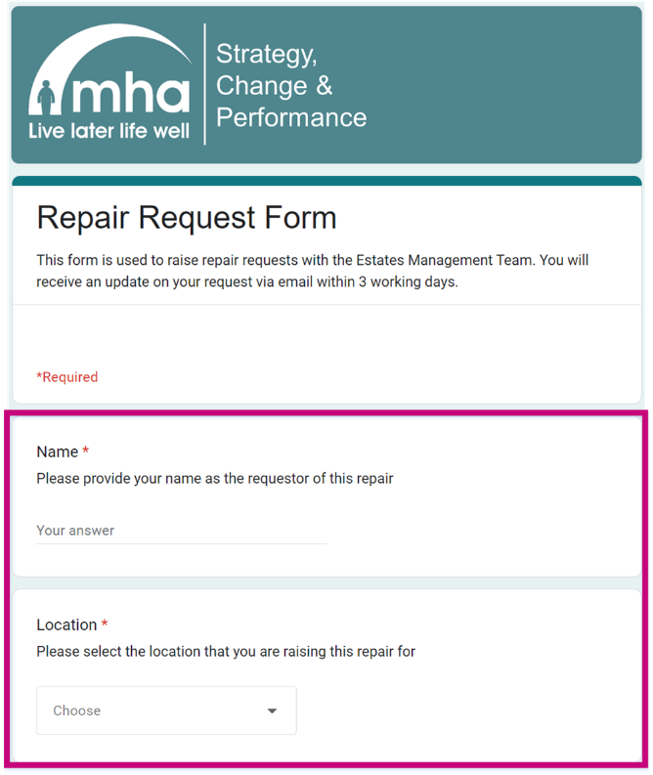
3 | MHA employee raising a repair request | Explain the issue | Provide the date the issue commenced. Give the issue a brief title. Describe the issue with as much information as possible making sure to include the room and floor location if applicable.  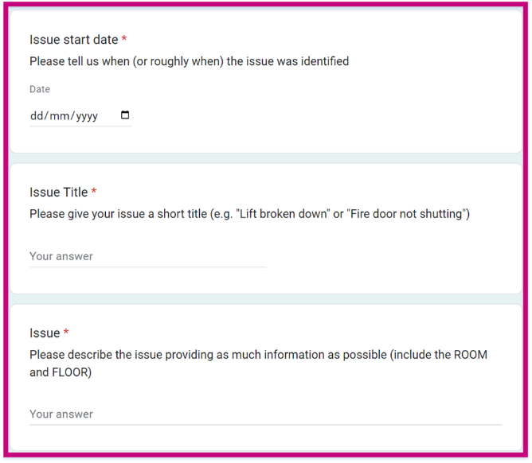
4 | MHA employee raising a repair request | Rate the urgency | Rate the urgency of the repair from 1-3 using the Urgency Guide to inform your selection. Please note that intentionally scoring a request as a higher priority than it actually is, will result in the repair being regraded. Repeat submissions that over inflate the priority will be raised with line managers.  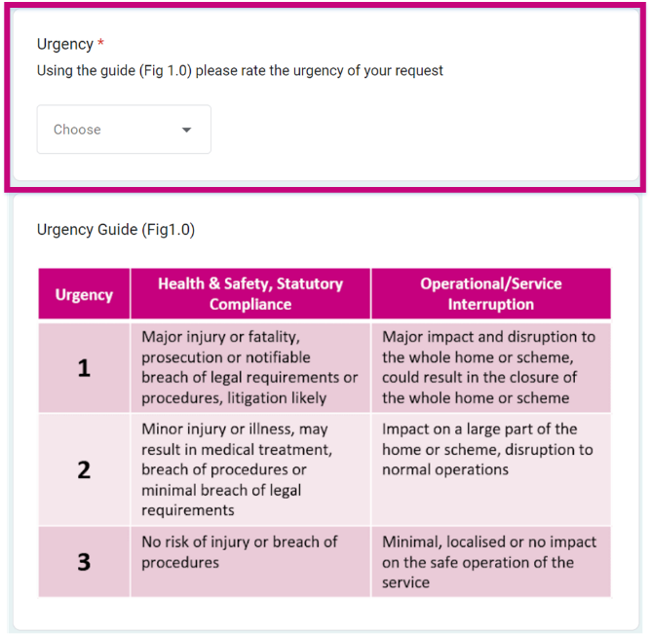
5 | MHA employee raising a repair request | Provide contact information and submit. | State whether a contractor has attended to this issue in the past. Provide your preferred contact number and email address. Click submit  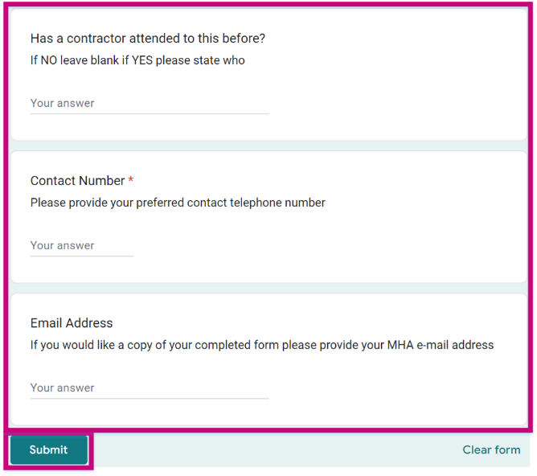

- Troubleshooting
  - Error made before submitting your information
If you’ve noticed an error in the information you are inputting but haven’t submitted the form yet, then you can easily:

- Click in the field and change the value

or

- Press the “Clear form” button at the bottom right of each page and start from the beginning of the form

  - Error in the information submitted
If you’ve already submitted incorrect information, please email the Estates Team on Estates.Admin@mha.org.uk.

You will be asked to resubmit the information, but please do not do this until you have spoken to the Estates Team and they have removed your incorrect request from the system.

